CST8285 Assignment 2 – Full Documentation
Project Title: Task Management Web Application
Course: CST8285 – Web Programming
Institution: Algonquin College
Submission Date: August 10, 2025

Team Members
- Backend Developer: Michael Chika Ekwezia

- Frontend Developer: Seyedarman Khoshnavapour
1. Web Map (Sitemap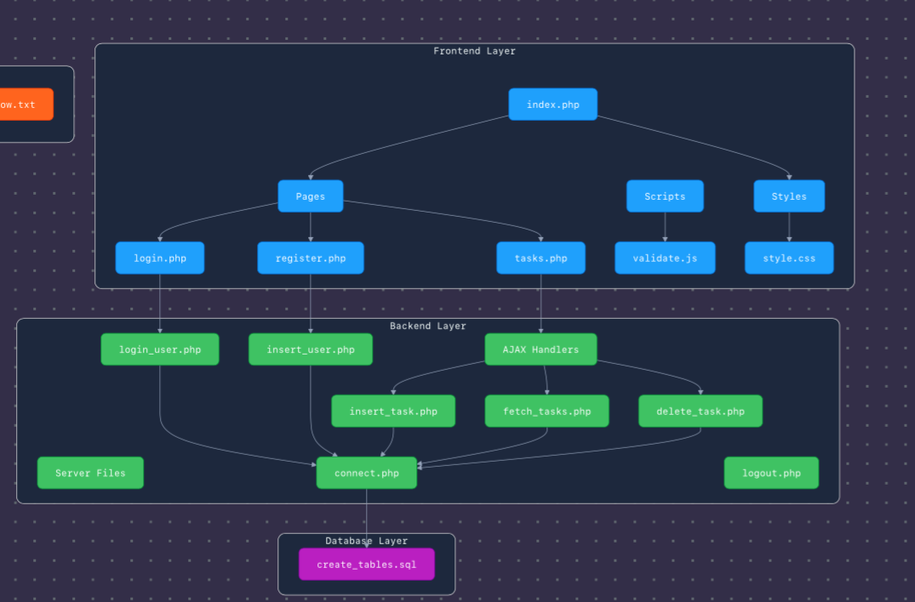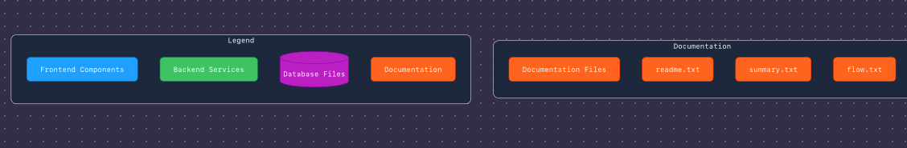

Figure 1: Application Web Map (Sitemap Diagram)

index.php (Landing Page)
├── pages/
│ ├── login.php (Login Form)
│ ├── register.php (User Registration)
│ └── tasks.php (User Dashboard)
│ ├── insert_task.php (Add Task - PHP + AJAX)
│ ├── fetch_tasks.php (Fetch Task List - PHP + AJAX)
│ └── delete_task.php (Delete Task - PHP + AJAX)
├── scripts/
│ └── validate.js (Client-side JS form validation)
├── server/
│ ├── login_user.php
│ ├── insert_user.php
│ ├── connect.php
│ ├── logout.php
├── database/
│ └── create_tables.sql (DB schema)
├── styles/
│ └── style.css
└── documentation/
├── readme.txt
├── summary.txt
└── flow.txt

2. Wireframes
SCREENSHOTS OF YOUR WEBSITE UI
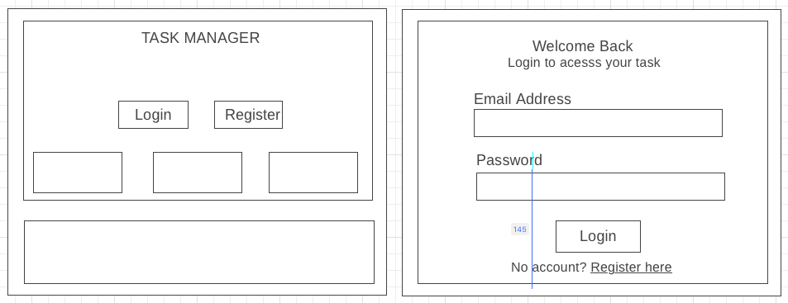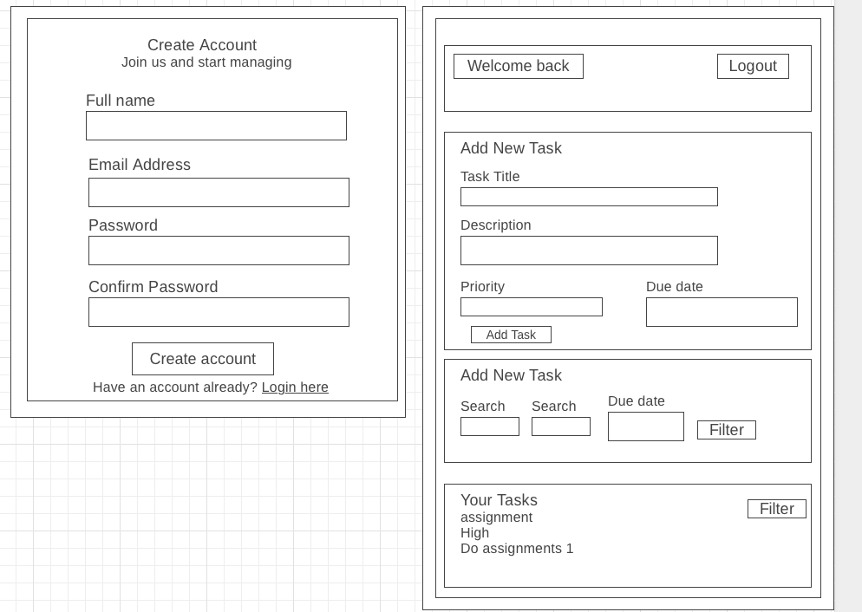

3. Code Attribution Table
Team Member | Responsibilities
Michael Chika Ekwezia | Backend development (PHP scripts, login/registration, task DB ops, sessions)
Seyedarman Khoshnavapour | Frontend design (CSS, animations), JavaScript validation, testing, mobile view

4. Special Coding Considerations
- JavaScript handles all client-side form validation (no HTML5 validation used)
- Passwords are stored using password_hash() (secure hashing)
- Prepared statements used for all SQL queries to prevent SQL injection
- Sessions control dashboard access (authenticated users only)
- AJAX used to add, fetch, and delete tasks dynamically
- CSRF protection implemented by checking session state
- Modern responsive UI using Flexbox, Grid, and glass morphism styling

5. System Execution Flow (User → PHP → DB → PHP → User)
A. Registration Flow:
- User fills form → JS validates → PHP (insert_user.php) → DB insert → session → dashboard

B. Login Flow:
- User submits login form → JS validation → PHP checks hash → session created → dashboard

C. Task Flow:
- Dashboard loads → AJAX calls fetch_tasks.php → PHP queries DB → tasks returned as JSON
- Add Task: JS validates → insert_task.php inserts to DB → AJAX updates view
- Delete Task: delete_task.php removes from DB → AJAX updates UI
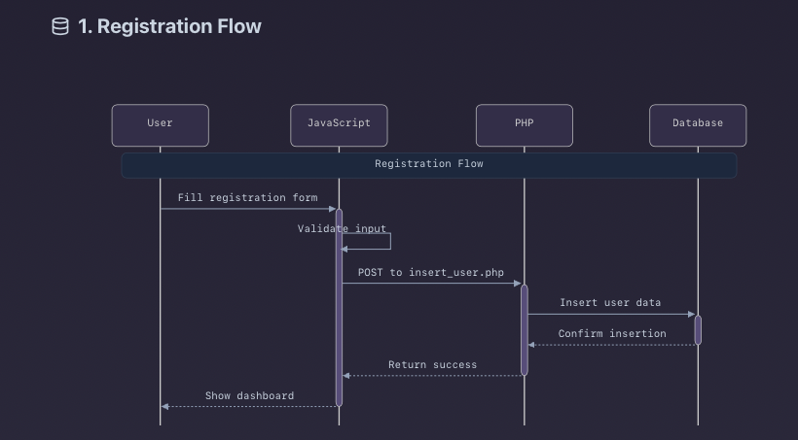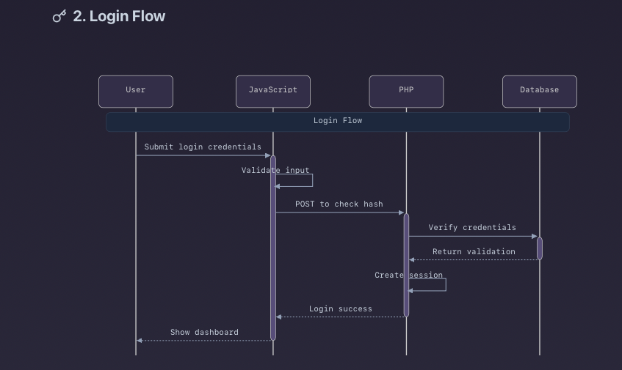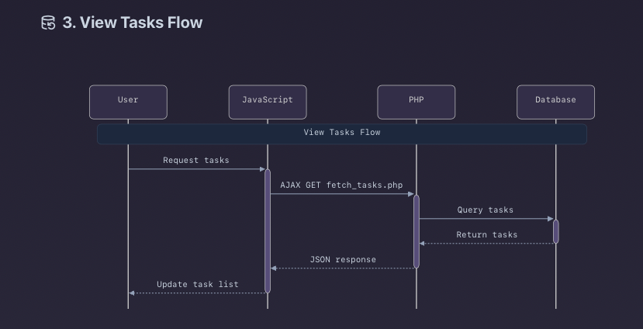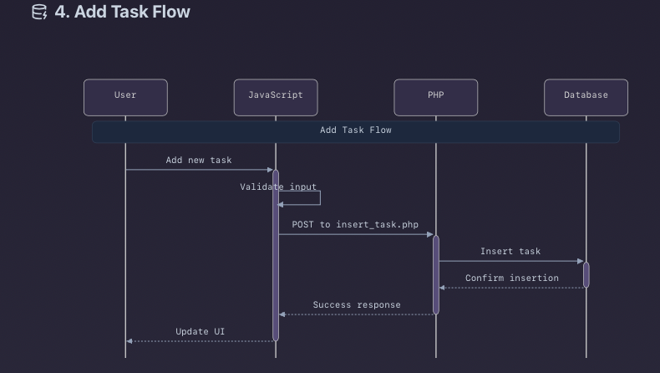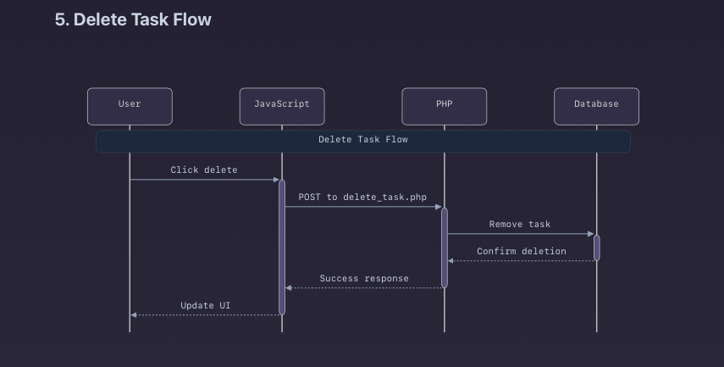

6. README Overview
CST8285 Assignment 2 - Task Management Web Application
Team Information:
- Lead Developer: Phil Maxwell-Mgbudem
- Review & Testing: Favour Adebayo
- Course: CST8285 – Web Programming
- Institution: Algonquin College

Project Overview
This is a full-featured task manager web app using HTML, CSS, JavaScript, PHP (procedural), and MySQL. No frameworks used. It demonstrates real-world use of form validation, database integration, and user authentication.

Key Features:
- User registration & login system
- Secure password hashing
- Add/delete/manage tasks
- AJAX-based filtering/search
- Responsive UI with gradients and glass morphism
- Full JavaScript validation
- Session authentication
- SQL injection prevention

Technology Stack:
- Frontend: HTML5, CSS3, Vanilla JavaScript
- Backend: PHP (procedural)
- Database: MySQL with mysqli
- Server: XAMPP (Apache + MySQL)

📁 Project File Structure:
pgsql
CopyEdit
task-manager/
├── index.php
├── pages/
│ ├── register.php
│ ├── login.php
│ └── tasks.php
├── scripts/
│ └── validate.js
├── server/
│ ├── connect.php
│ ├── insert_user.php
│ ├── login_user.php
│ ├── insert_task.php
│ ├── fetch_tasks.php
│ ├── delete_task.php
│ └── logout.php
├── styles/
│ └── style.css
├── database/
│ └── create_tables.sql
└── documentation/
├── readme.txt
├── summary.txt
└── flow.txt

⚙️ Installation Instructions:
- Install XAMPP
- Start Apache and MySQL
- Copy folder to /htdocs/
- Import create_tables.sql in phpMyAdmin
- Open http://localhost/task-manager

7. Summary of Application Functionality
User Registration
- User enters name, email, password
- JS validates input in real-time
- Data submitted to insert_user.php
- PHP hashes password, checks duplicates
- User is logged in and redirected to dashboard

User Login
- User enters email and password
- JS validation runs
- Data goes to login_user.php
- PHP verifies hash, starts session
- Redirects on success or shows error

📋 Task Dashboard
- Tasks fetched via fetch_tasks.php using AJAX
- Add task form submits via JS → insert_task.php
- Delete task uses delete_task.php via AJAX
- Filter and search use input + dropdowns to narrow list

Database Structure
users Table:
- id, name, email, password, created_at
- Passwords hashed, email is unique
tasks Table:
- id, user_id, title, description, priority, due_date, created_at
- Foreign key user_id references users.id
- Cascade delete: if user is deleted, tasks are removed

Security Summary
- Hashed passwords (password_hash)
- Prepared statements for DB ops
- Sessions protect all user pages
- Client + server validation
- CSRF protection via session checks

UI Features
- Glass morphism: blurred card containers
- Purple-to-blue gradient background
- Fully responsive for desktop & mobile
- Real-time validation + error messages
- Task priorities color-coded (e.g., red for High)

8. System Flow Summary
Registration:
- JS validates inputs
- PHP hashes and stores user
- Session started → redirect to dashboard
Login:
- JS checks form
- PHP verifies password
- Session → dashboard or error shown
Tasks:
- Dashboard loads AJAX tasks
- Add task → validated → PHP inserts → list refreshes
- Delete task → PHP deletes → list updates

